Digital Storytelling Club
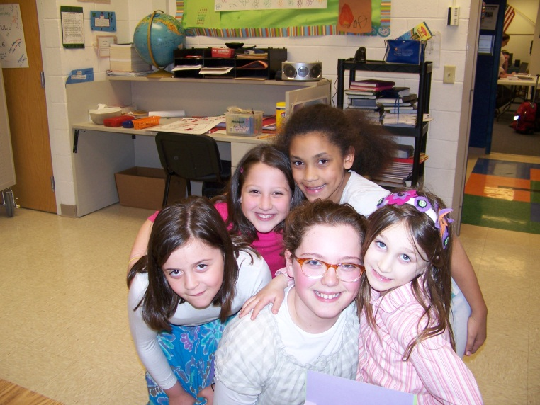 |  |  |  | Last week our Hillel Storytellers had a little help from their friends in the Year Book Club. We thank you Leigh, Mushkie, Nathan and Miss Jen for your time and kindness!
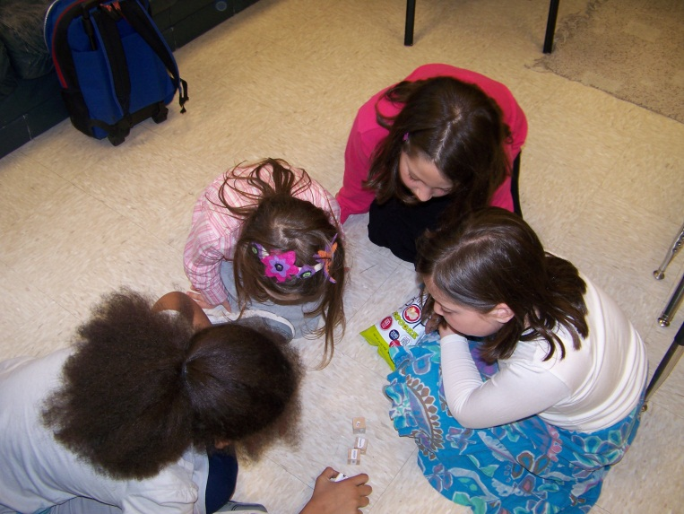 |  |  |  |  | 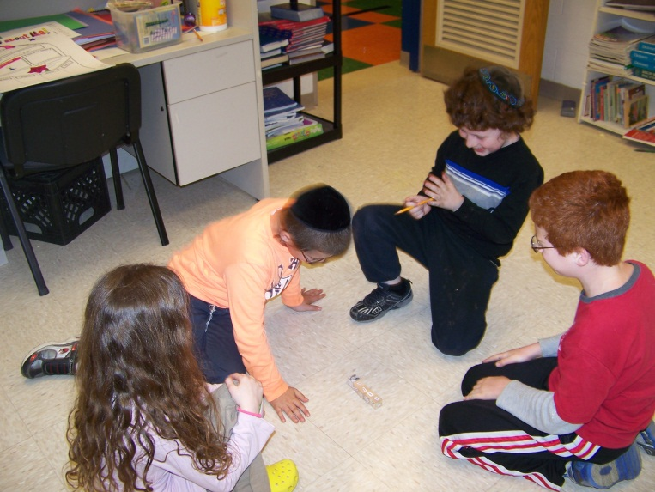
The students broke into two groups and took turns “shaking” a story. The students used the storytelling dice we created in our 2nd meeting. |  |  |  |  | I added a couple of new dice with the students’ pictures! Students shook 5 dice (one contained the students’ faces) and then had to tell a story.
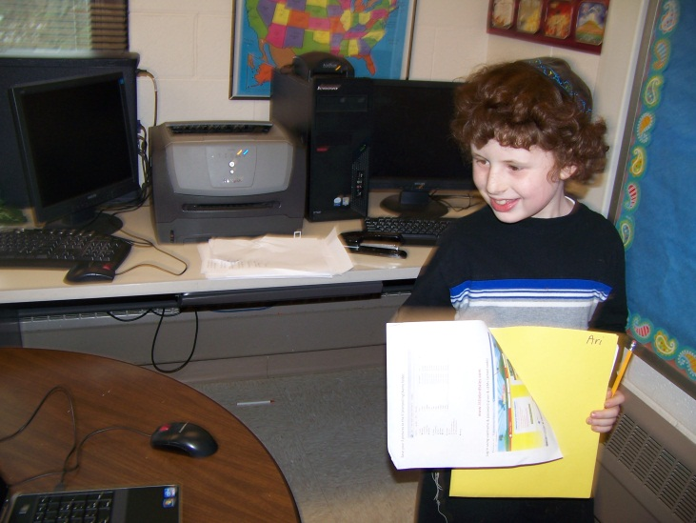 |  |  | 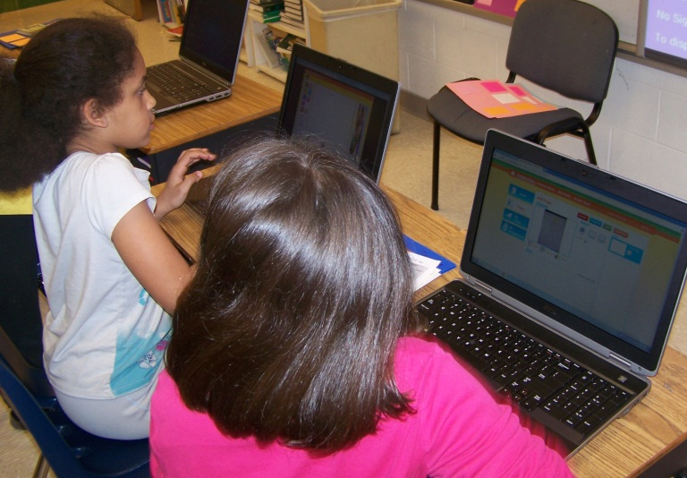
Ari just finished recording his introduction on our newest VoiceThread. |  |  | Jaycelan and Rachel are busy working on their stories on Little Bird Tales.
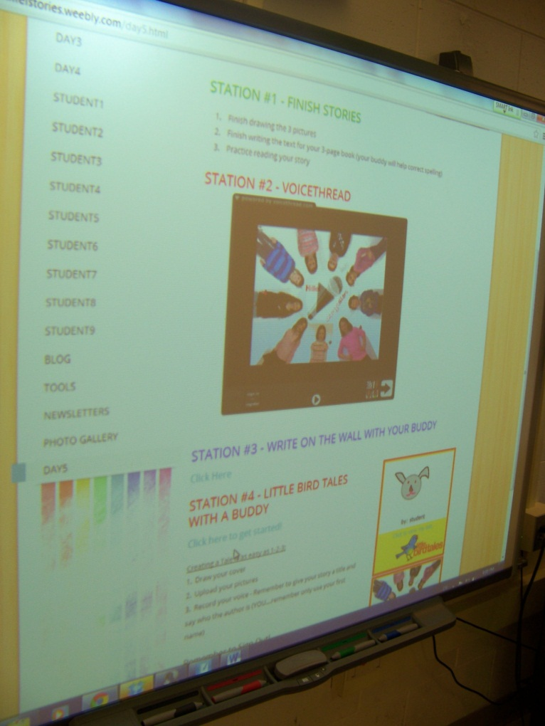 |  | 5/09/13  Each week we review what we will  work on for that day. The Hillel Stories  website details our day.  Visit www.hillelstories.weebly.com to see what we’ve been working on.  This week we worked on finishing our first short story: illustrating, writing the text and uploading the images, typing our text and recording our stories online.  The students are using www.littlebirdtales.com to create their digital stories.
Chaiky is recording her story in Little Bird Tales, while Ellie is putting pen to paper and planning her next story. | 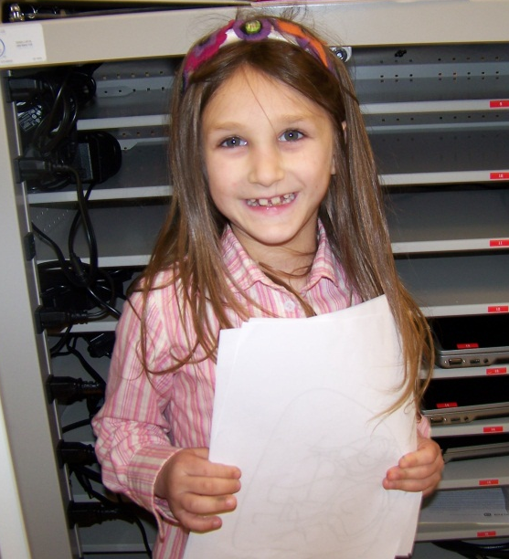  Avigayil is all smiles, because she just finished illustrating her second story! |  |  |  |  | 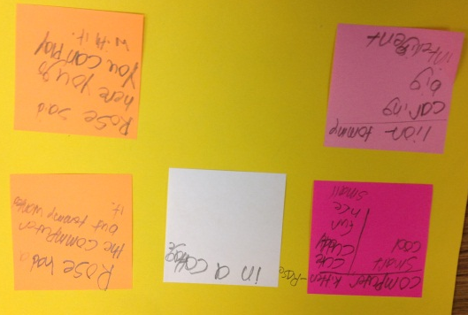  Students started planning for their next stories:  - Pink sticky notes = name or describe characters  - White sticky note = setting  - Orange sticky notes = the conflict/problem and resolution.

